1. **Information Security**
2. **Chapter 10: Intrusion Data Analysis**
4. Lab 37 - Extract an Executable from a PCAP

# Objectives

Part 1: Analyze Pre-Captured Logs and Traffic Captures.

Part 2: Extract Downloaded Files from PCAP.

# Background / Scenario

Looking at logs is very important, but it is also important to understand how network transactions happen at the packet level.

In this lab, you will analyze the traffic in a previously captured pcap file and extract an executable from the file.

# Required Resources

* CyberOps Workstation virtual machine

# Instructions

## Analyze Pre-Captured Logs and Traffic Captures

In Part 2, you will work with the **nimda.download.pcap** file. Captured in a previous lab, **nimda.download.pcap** contains the packets related to the download of the Nimda malware. Your version of the file, if you created it in the previous lab and did not reimport your CyberOps Workstation VM, is stored in the /home/analyst directory. However, a copy of that file is also stored in the **CyberOps Workstation VM**, under the **/home/analyst/lab.support.files/pcaps** directory so that you can complete this lab. For consistency of output, the lab will use the stored version in the **pcaps** directory.

While **tcpdump** can be used to analyze captured files, **Wireshark’s** graphical interface makes the task much easier. It is also important to note that **tcpdump** and **Wireshark** share the same file format for packet captures; therefore, PCAP files created by one tool can be opened by the other.

* + - 1. Change directory to the **lab.support.files/pcaps** folder, and get a listing of files using the **ls –l** command.

[analyst@secOps ~]$ **cd lab.support.files/pcaps**

[analyst@secOps pcaps]$ **ls -l**

total 7460

-rw-r--r-- 1 analyst analyst 3510551 Aug 7 15:25 lab_prep.pcap

-rw-r--r-- 1 analyst analyst 371462 Jun 22 10:47 nimda.download.pcap

-rw-r--r-- 1 analyst analyst 3750153 May 25 11:10 wannacry_download_pcap.pcap

[analyst@secOps pcaps]$

* + - 1. Issue the command below to open the **nimda.download.pcap** file in Wireshark.

[analyst@secOps pcaps]$ **wireshark nimda.download.pcap &**

* + - 1. The **nimda.download.pcap** file contains the packet capture related to the malware download performed in a previous lab. The **pcap** contains all the packets sent and received while **tcpdump** was running. Select the fourth packet in the capture and expand the Hypertext Transfer Protocol to display as shown below.

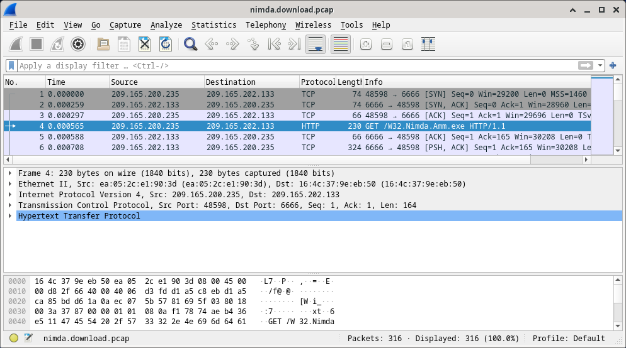

* + - 1. Packets one through three are the TCP handshake. The fourth packet shows the request for the malware file. Confirming what was already known, the request was done over HTTP, sent as a GET request.
      2. Because HTTP runs over TCP, it is possible to use **Wireshark**’s **Follow TCP Stream** feature to rebuild the TCP transaction. Select the first TCP packet in the capture, a SYN packet. Right-click it and choose **Follow** > **TCP Stream**.

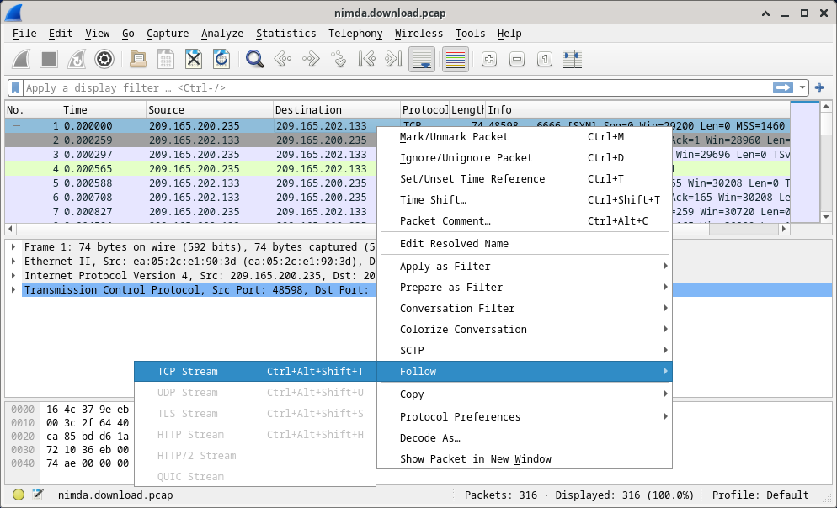

* + - 1. Wireshark displays another window containing the details for the entire selected TCP flow.

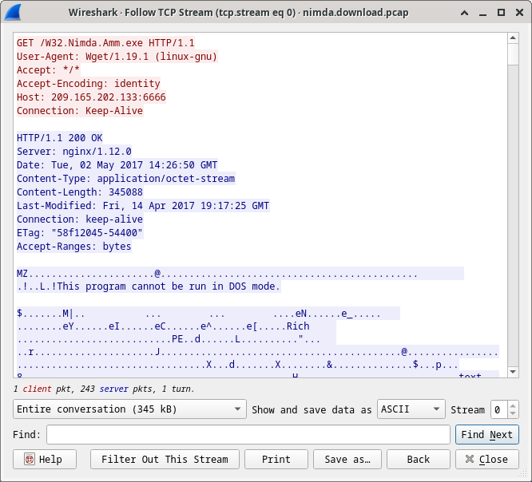

#### Questions:

What are all those symbols shown in the **Follow TCP Stream** window? Are they connection noise? Data? Explain.

***Ans:*** The images are the genuine substance of the downloaded record. Since it is twofold record, Wireshark does not know how to speak to it. The shown images are Wireshark’s best figure at making sense of the twofold information whereas translating it as content.

There are a few readable words spread among the symbols. Why are they there?

***Ans:*** Those are strings contained within the executable code. More often than not, these words are portion of messages given by the program to the client whereas it runs. Whereas more of an craftsmanship than a science, a talented examiner can extricate profitable data by perusing through these parts.

**Challenge Question:** Despite the **W32.Nimda.Amm.exe** name, this executable is not the famous worm. For security reasons, this is another executable file that was renamed as **W32.Nimda.Amm.exe**. Using the word fragments displayed by **Wireshark**’s **Follow TCP Stream** window, can you tell what executable this really is?

***Ans:*** Looking over all the way down on that window uncovers that usually the Microsoft Windows cmd.exe record.

* + - 1. Click **Close** in the Follow TCP Stream window to return to the Wireshark nimda.download.pcap file.

## Extract Downloaded Files from PCAP

Because capture files contain all packets related to traffic, a PCAP of a download can be used to retrieve a previously downloaded file. Follow the steps below to use **Wireshark** to retrieve the Nimda malware.

* + - 1. In that fourth packet in the **nimda.download.pcap** file, notice that the **HTTP GET** request was generated from **209.165.200.235** to **209.165.202.133**. The Info column also shows this is in fact the GET request for the file.
      2. With the GET request packet selected, navigate to **File > Export Objects > HTTP**, from **Wireshark**’s menu.

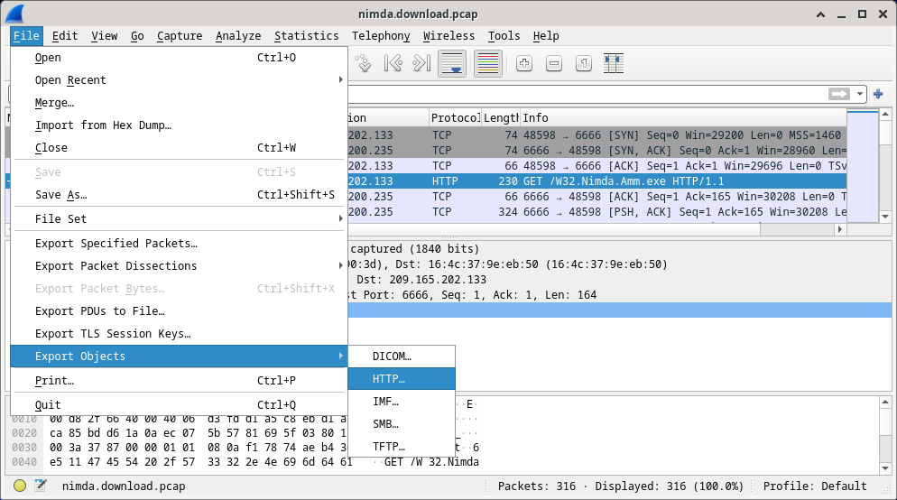

* + - 1. Wireshark will display all HTTP objects present in the TCP flow that contains the GET request. In this case, only the **W32.Nimda.Amm.exe** file is present in the capture. It will take a few seconds before the file is displayed.

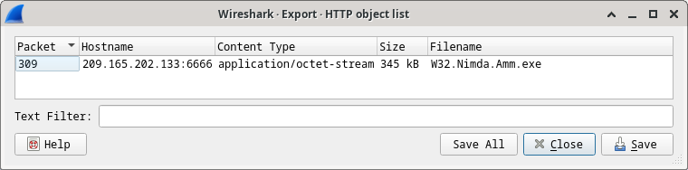

#### Question:

Why is **W32.Nimda.Amm.exe** the only file in the capture?

***Ans:*** Since the capture was begun right some time recently the download and ceased right after. No other activity was caught whereas the capture was dynamic.

* + - 1. In the **HTTP object list** window, select the **W32.Nimda.Amm.exe** file and click **Save As** at the bottom of the screen.
      2. Click the left arrow until you see the **Home** button. Click Home and then click the **analyst** folder (not the analyst tab). Save the file there.
      3. Return to your terminal window and ensure the file was saved. Change directory to the **/home/analyst** folder and list the files in the folder using the **ls -l** command.

[analyst@secOps pcaps]$ **cd /home/analyst**

[analyst@secOps ~]$ **ls –l**

total 364

drwxr-xr-x 2 analyst analyst 4096 Sep 26 2014 Desktop

drwx------ 3 analyst analyst 4096 May 25 11:16 Downloads

drwxr-xr-x 2 analyst analyst 4096 May 22 08:39 extra

drwxr-xr-x 8 analyst analyst 4096 Jun 22 11:38 lab.support.files

drwxr-xr-x 2 analyst analyst 4096 Mar 3 15:56 second_drive

-rw-r--r-- 1 analyst analyst 345088 Jun 22 15:12 W32.Nimda.Amm.exe

[analyst@secOps ~]$

#### Question:

Was the file saved?

***Ans:*** Yes.

* + - 1. The **file** command gives information on the file type. Use the file command to learn a little more about the malware, as show below:

[analyst@secOps ~]$ **file W32.Nimda.Amm.exe**

W32.Nimda.Amm.exe: PE32+ executable (console) x86-64, for MS Windows

[analyst@secOps ~]$

As seen above, **W32.Nimda.Amm.exe** is indeed a Windows executable file.

#### Question:

In the malware analysis process, what would be a probable next step for a security analyst?

***Ans:*** The objective is to recognize the sort of malware and analyze its behavior. Hence, the malware record ought to be moved to a controlled environment and execute it to observe its behavior. Malware examination situations regularly depend on virtual machines and are sandboxed to dodge harm to non-test frameworks. Such situations ordinarily contain apparatuses that encourage observing of the malware execution; assets utilization, organize associations and working framework changes are common checked perspectives.